Creating the dataset

Csv file

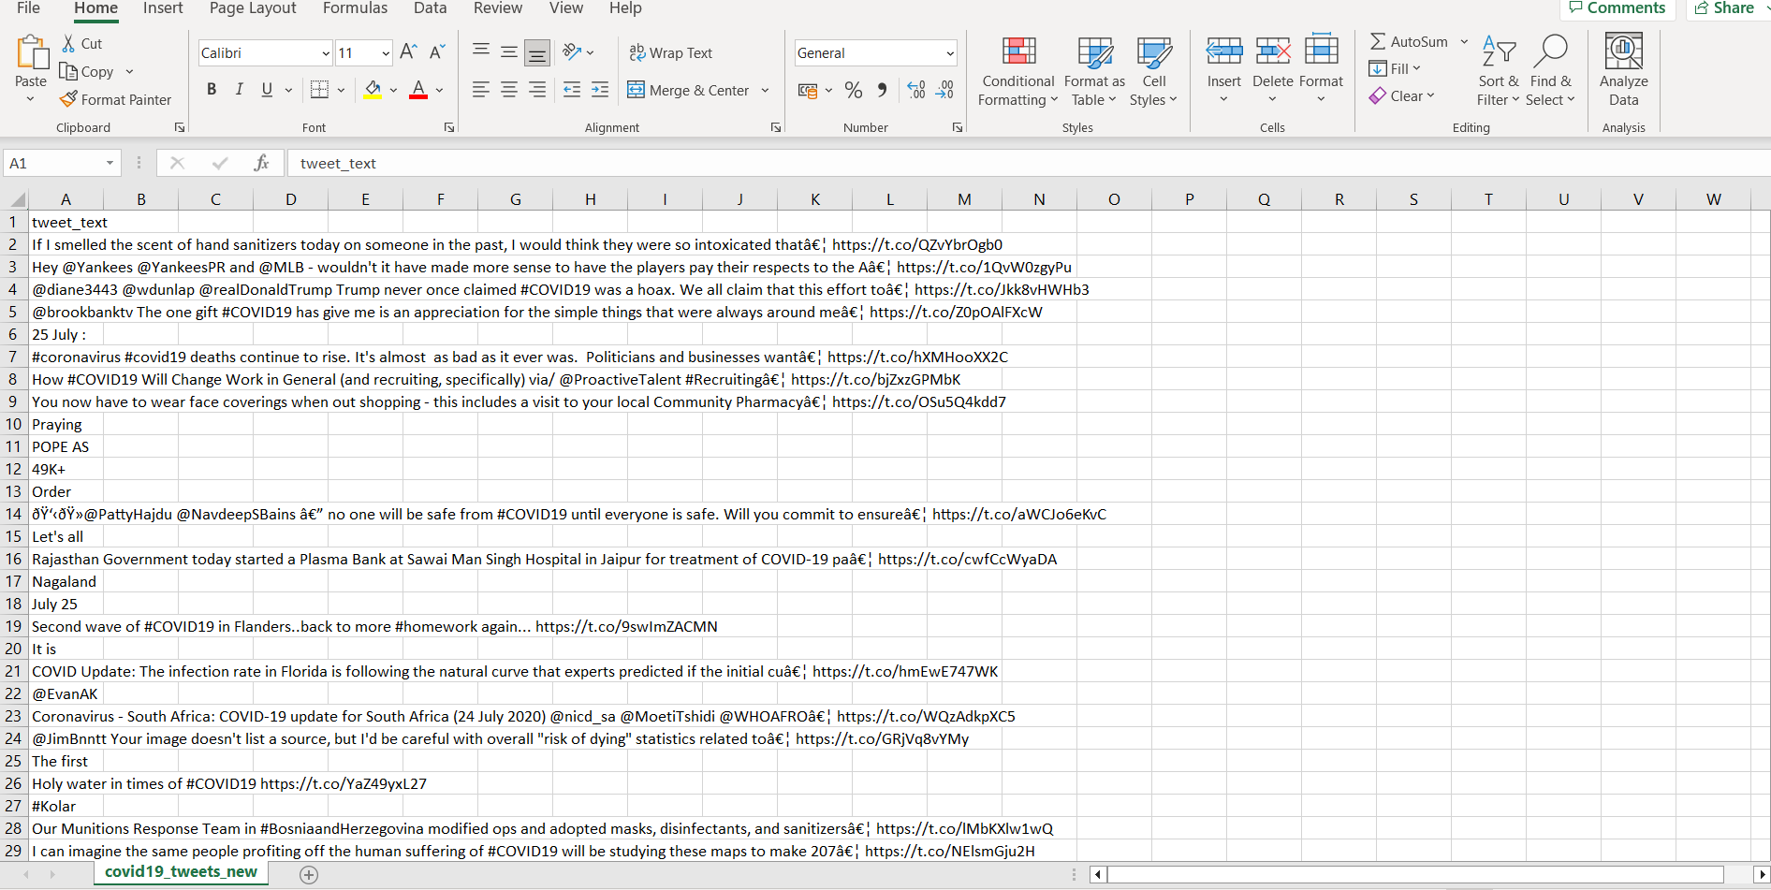

Creating azure dataset

